# ASSIGNMENT (4-09-25 & 5-09-25)

Submitted by : Srividya Arul Raju(23KQ5A0206)

1. To check factorial number.

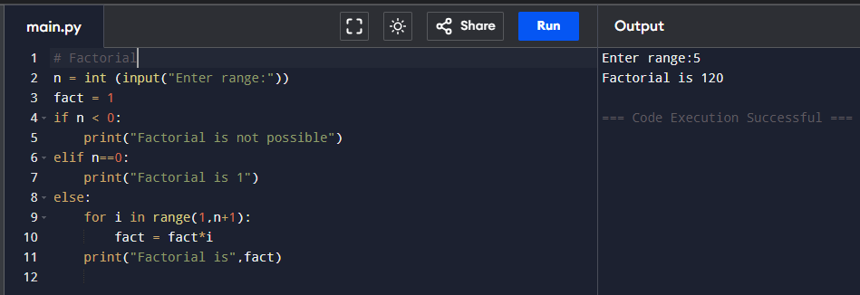

1. 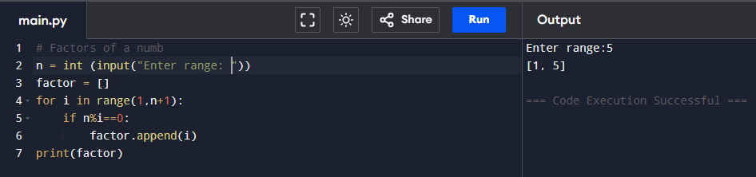Factors of number.
2. 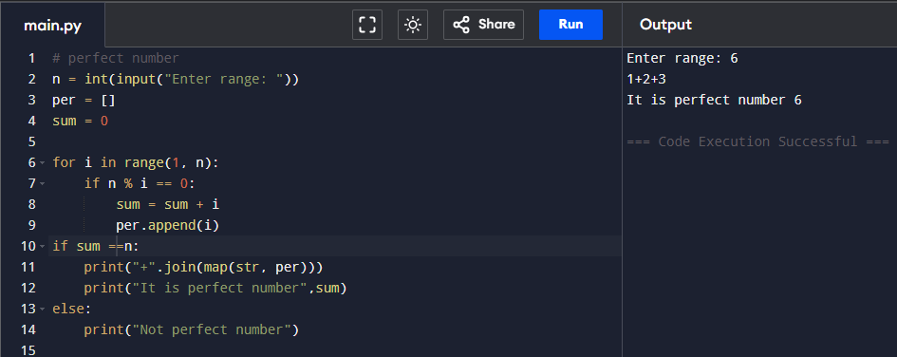Perfect number
3. Perfect square number
4. 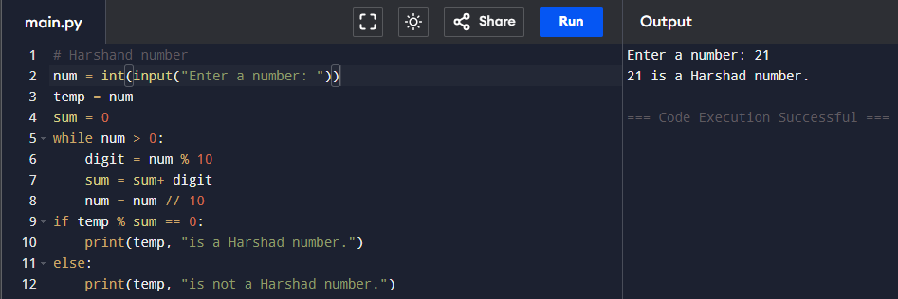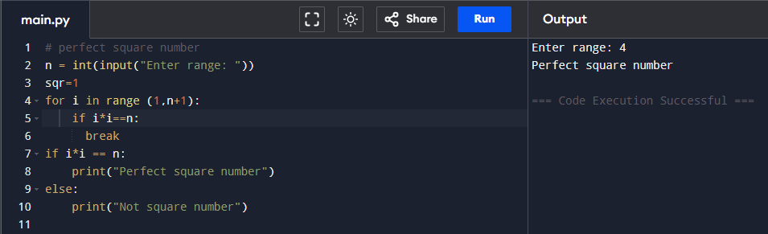Harshand number.
5. 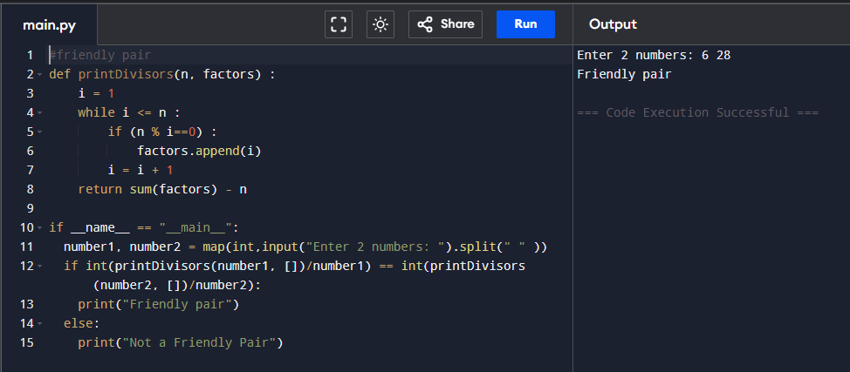Friendly pair.
6. Abudant number.

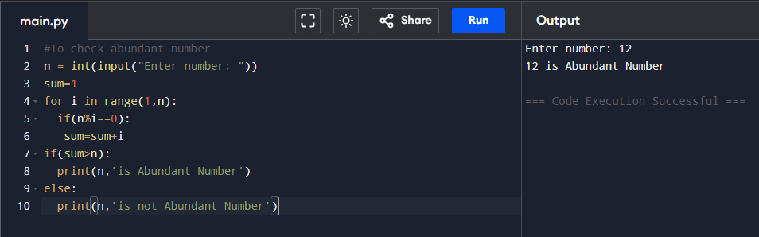

1. Automorphic number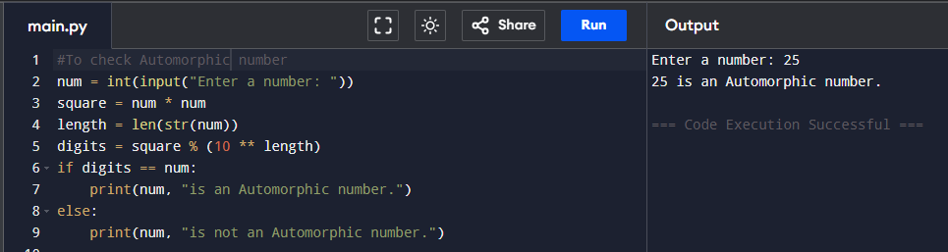
2. Strong number

